# AIM:

VISUALIZEDATAUSINGANYPLOTTINGFRAMEWORK

ToimplementavisualizeDatausinganyplottingframeworkusingRStudio.

# SCATTERPLOT

#ScatterplotofSepal.LengthvsSepal.Width,coloredbySpeciesggplot(data

=iris,aes(x=Sepal.Length,y=Sepal.Width,color=Species))

+ geom_point(size = 3) + # Adds pointslabs(title ="ScatterPlotofSepalDimensions", x="SepalLength(cm)", y = "Sepal Width (cm)") + # Adds axis labelsandtitletheme_minimal()#Applies aminimaltheme

# OUTPUT:

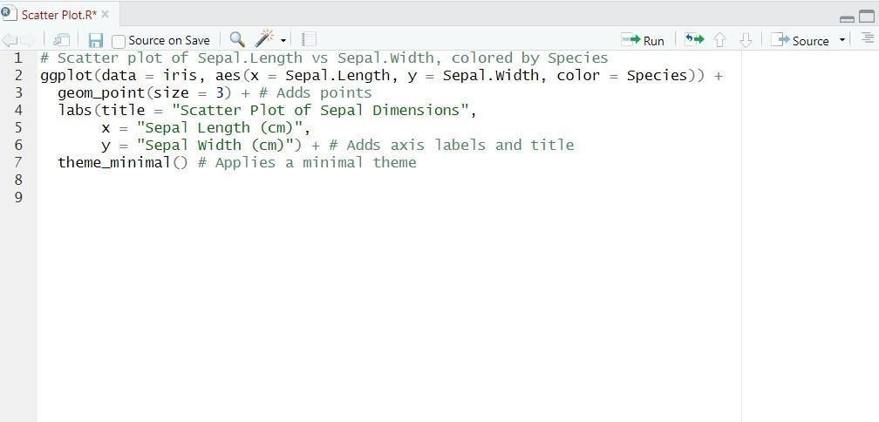

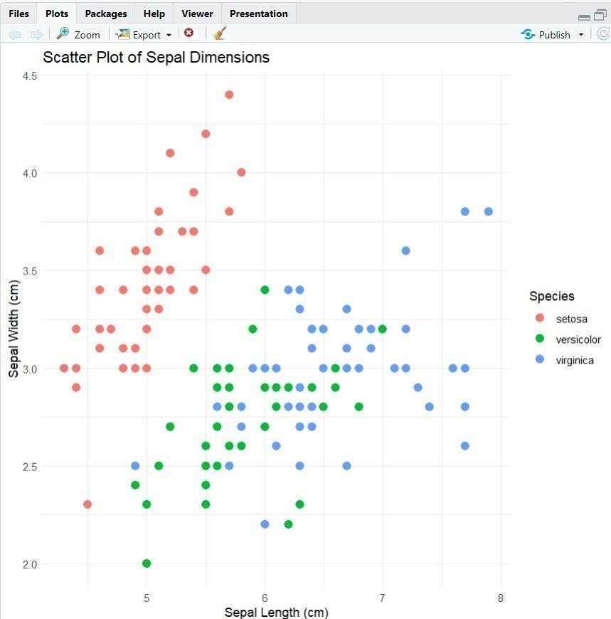

1. **BARCHART**

#Installggplot2(ifnotalreadyinstalled)install.packages("ggplot2")

#Loadtheggplot2packagelibrary(ggplot2)

#Barplotof Speciescountsggplot(data

=iris, aes(x =Species))+ geom_bar(fill = "steelblue") +# Addsbarsfilledwithsteelblue color labs(title = "Count of DifferentSpeciesinIris

Dataset", x="Species", y="Count")+theme_minimal()**OUTPUT:**

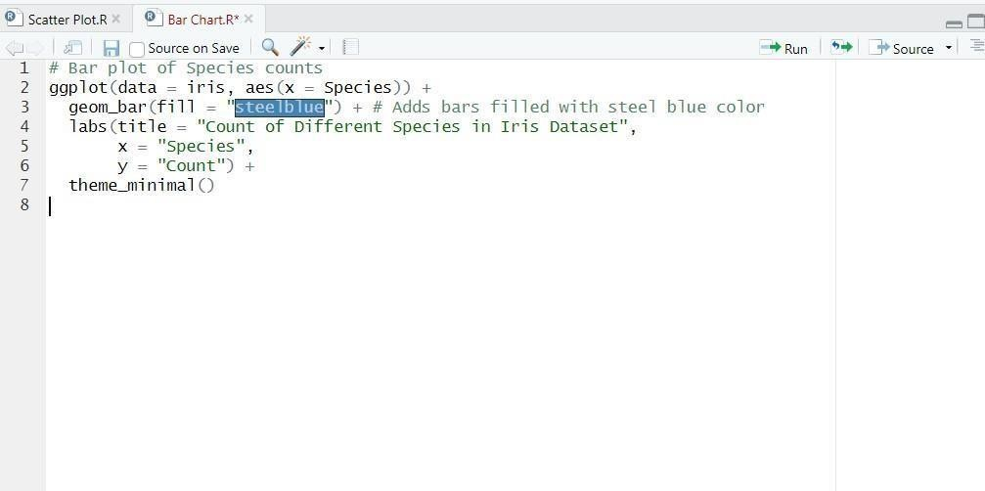

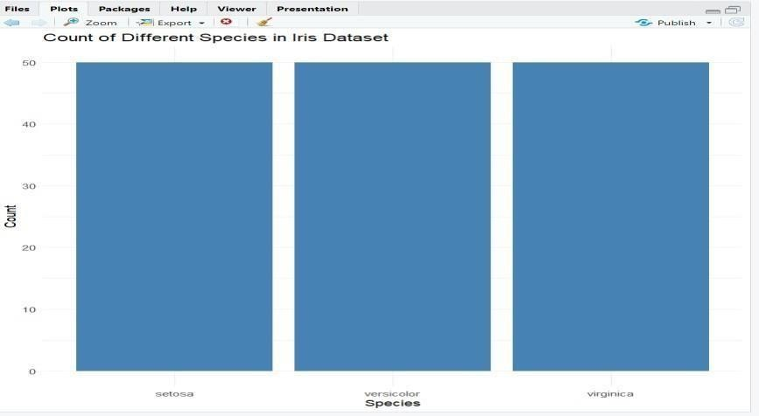

# HISTOGRAM

#Installggplot2(ifnotalreadyinstalled)install.packages("ggplot2")

#Loadtheggplot2packagelibrary(ggplot2)

#HistogramofSepalLength

ggplot(data=iris, aes(x =Sepal.Length))+

geom_histogram(binwidth=0.3,fill="orange",color="black")+#Addshistogrambars labs(title="Histogram of Sepal

Length", x="SepalLength(cm)", y

= "Frequency") +theme_minimal()

# OUTPUT:

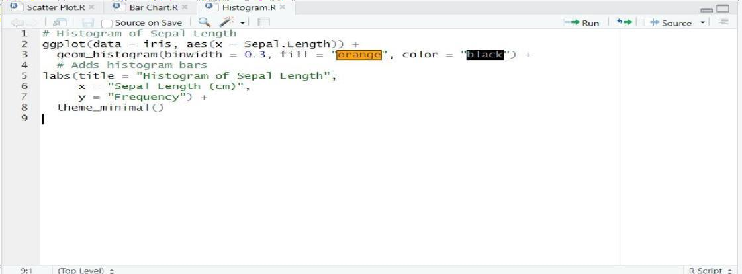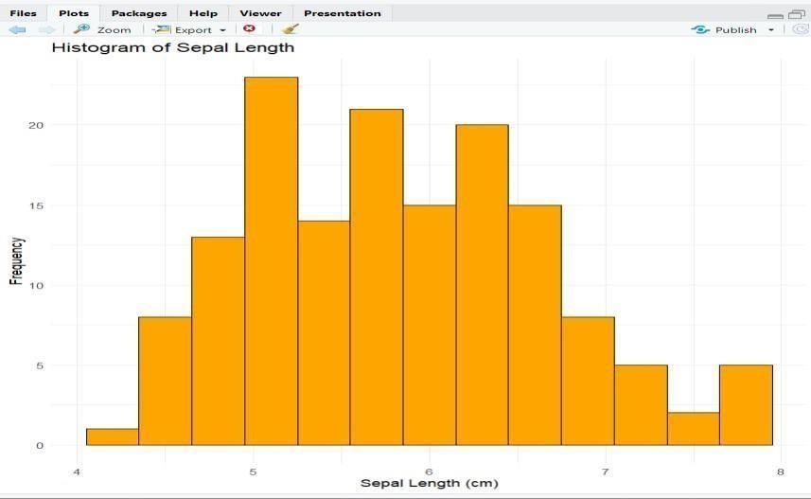

1. **BOXPLOT**

#Installggplot2(ifnotalreadyinstalled)install.packages("ggplot2")

#Loadtheggplot2packagelibrary(ggplot2)

#BoxplotofSepal LengthforeachSpeciesggplot(data=iris,aes(x

=Species,y=Sepal.Length,fill=Species))

+geom_boxplot()+#Addsboxplotlabs(title="BoxPlot of

SepalLengthby Species", x="Species", y="SepalLength(cm)")+theme_minimal()

# OUTPUT:

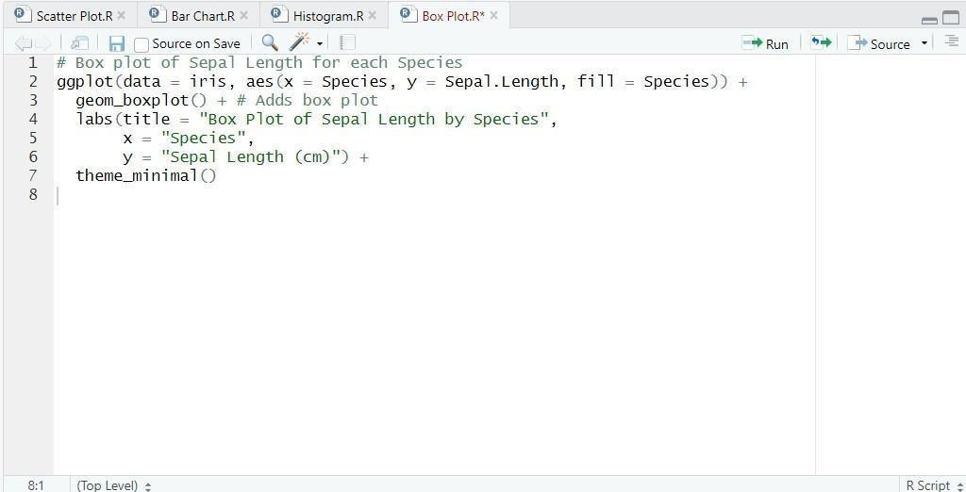

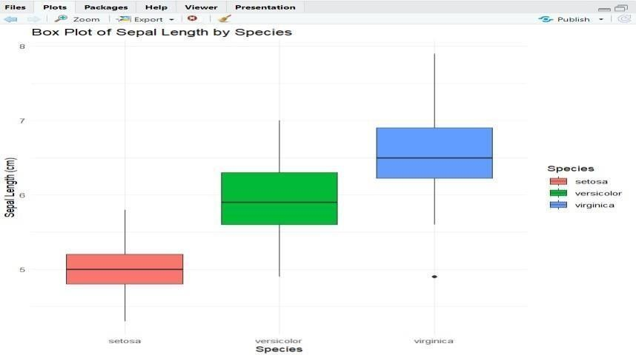

**RESULT:**

Thus,thevisualizeDatausinganyplottingframeworkusingRStudiohavebeensuccessfullyexecuted.